HYNISH CENTRE
ISLE OF TIREE

BUSINESS PLAN

Created by

TIREE COMMUNITY DEVELOPMENT TRUST
“TCDT”

On behalf of

NEW CHARITABLE SUBSIDIARY “NEWCS”

September 2017

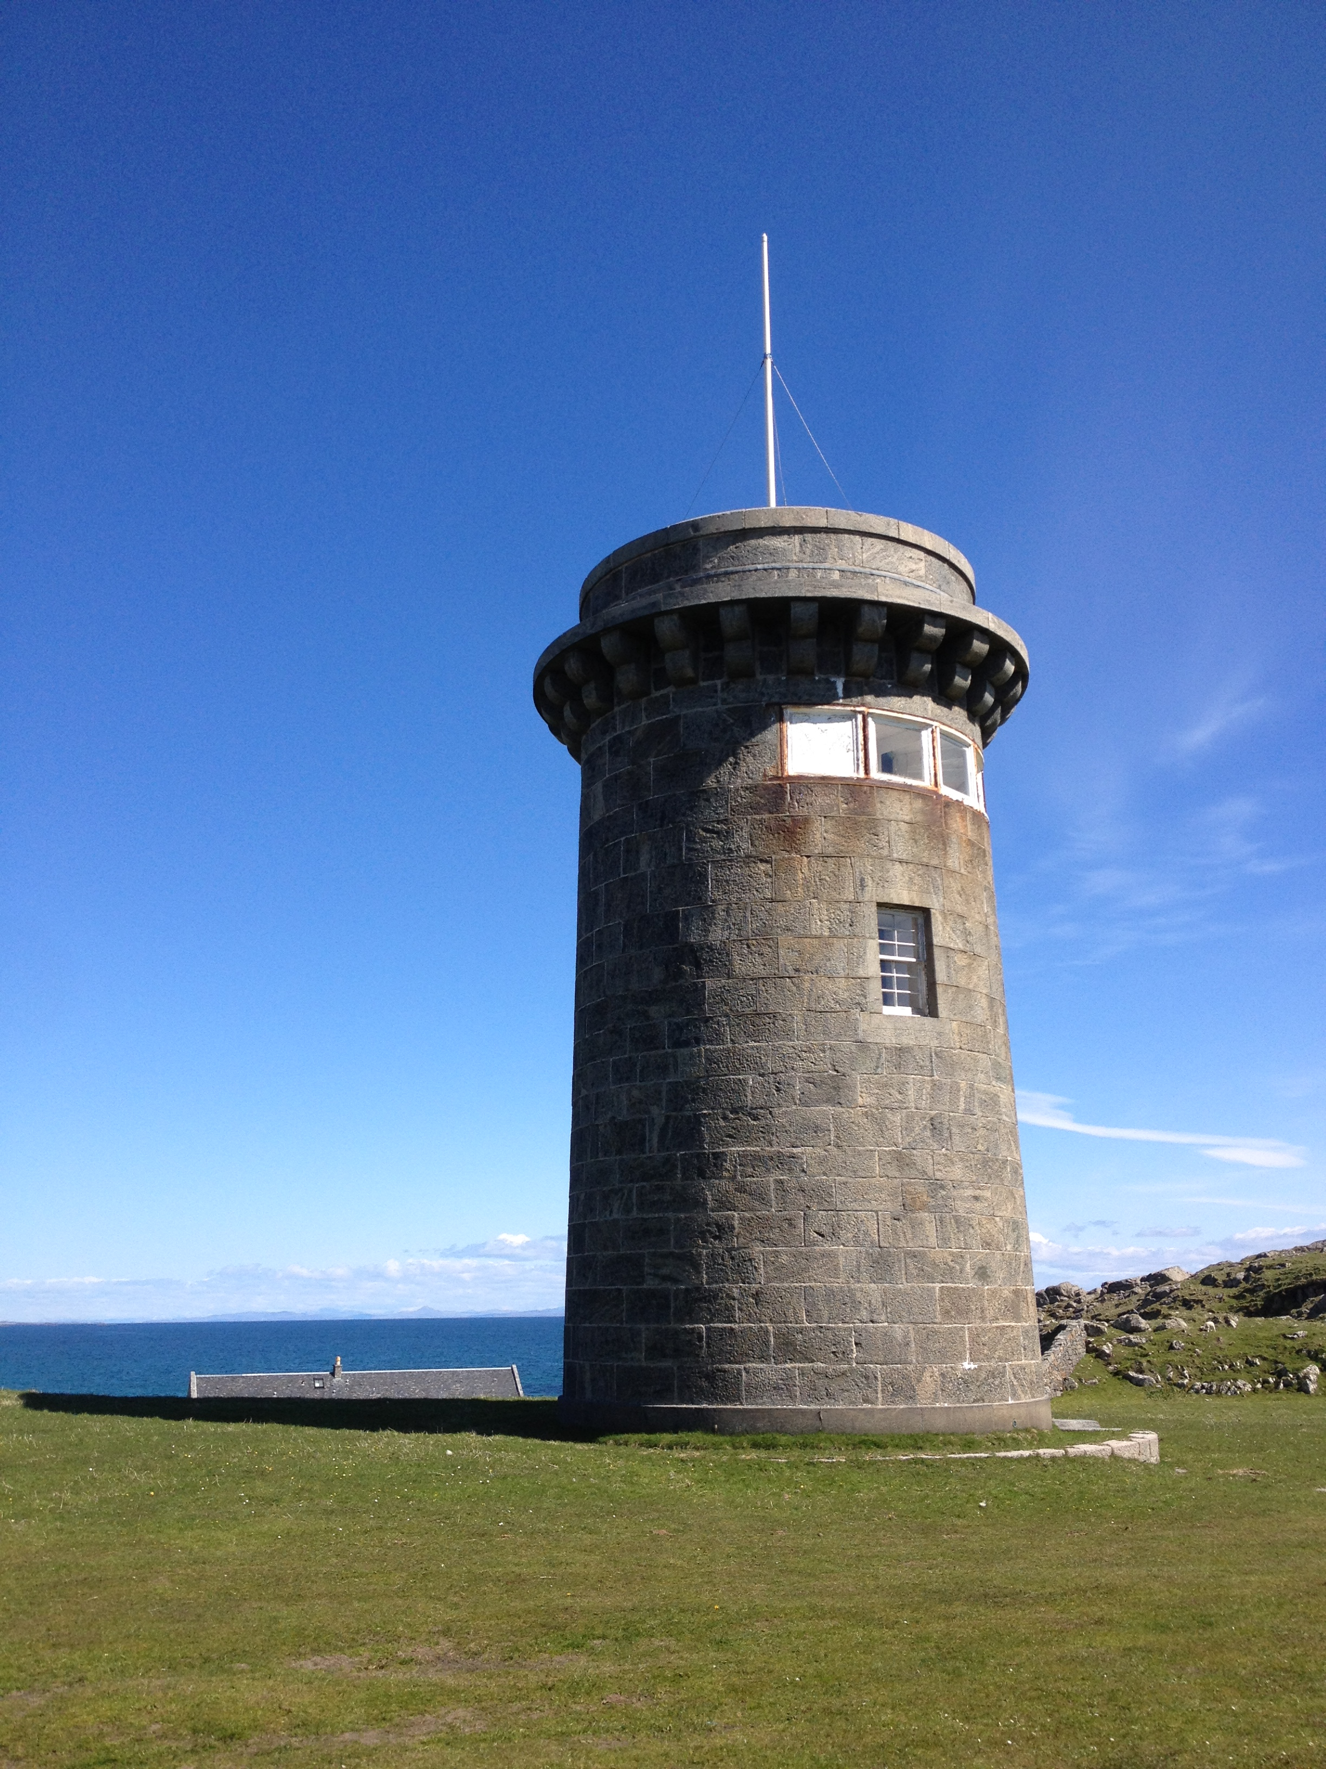

INDEX

Table of Contents
HYNISH CENTRE 1
1. Executive Summary 4
1.1 ‘Hynish – Tiree’s Heritage, Past and Future’ 4
2. Background 6
2.1 Introduction 6
3. Surveyors (ARPL) Reports on Current Conditions 8
4. Future Vision of Community Ownership 9
4.1 Vision 9
4.2 Key Objectives 9
4.3 Keys to Success 10
5. Corporate Structure post acquisition 11
5.1 Legal status of current owners 11
5.2 New legal entity (NewCS) 11
5.3 NewCS’s tax and accounting strategies 11
6. Development Potential 12
7. Employment Opportunities 13
8. Funding 13
8.1 Proposed renovation and restoration costs 13
8.2 Proposed future developments 14
9. Financial Models 15

Executive Summary

1.1 ‘Hynish – Tiree’s Heritage, Past and Future’

The Group of buildings at Hynish, Isle of Tiree “are as a group, and in their relation to Skerryvore, unique in Scotland and survive in a good sympathetic state recognised by its listing at the highest level.” (Extract from Surveyors report August 2016).

  - Introduction
Tiree has a successful record of community-led initiatives to address needs and deliver the infrastructure necessary for economic growth. These include:
- An Talla, the community-owned hall and base for many activities including the Tiree Music Festival, and the annual 10k and ultra-marathon races;
- The island’s Maritime Trust keeps the heritage of traditional dipping lug sailing alive. With its award winning centre ‘The Noust’ it has provided training opportunities in traditional boat building skills;
- A grassroots windsurfing movement has grown into a mainstay of the local tourism sector, anchored annually by a locally managed international windsurf competition;
- The Rural Centre which provides an auction mart for the crofting sector and a popular café;
- Community ownership of two buildings - the base for a local shop Buth à Bhaile, and the Island Centre which provides office space for public services and businesses;
- Community-owned Tiree Broadband which has addressed serious shortcomings in the island’s IT infrastructure and is a standard model for such organisations;
- Project officer posts which develop specific areas of development including a Youth Worker, a Music and Culture Coordinator and Environmental Ranger. Much of this has been possible due to income generated by Tiree Community Development Trust’s subsidiary, Tiree Renewable Energy Ltd, which owns and operates the community wind turbine. This was one of the first such in Scotland and provided the model for many others across the country.

  - Tiree Growth Plan
The Tiree Growth Plan covering 2017 to 2020 identified the opportunity to acquire the Hynish Centre to:
- Create sustainable jobs
- Provide affordable housing
- Promote our culture and heritage
- Encourage sustainable tourism

  - The Growth Imperative

In common with most west coast islands, Tiree’s population has been in decline for decades. It fell from 770 to 653 between the 2001 and 2011 censuses. The school roll of 83 plus pre-school of 24 is close to the all-time low. The secondary stage is the smallest six-year secondary school in Scotland (Scottish Government School Estate Core Facts 2016), and the least accessible.

Although in recent years population decline has occurred across each of the broad age categories, some individual age groups bucked this trend with 18-24 year olds living on Tiree being 15% higher in 2011 than in 2001. If this group can be encouraged to stay on Tiree (followed by subsequent cohorts in future years) there could be more adults within the typical family-age bracket, with potential positive implications for the number of children over future years.

1.5 The Opportunity

TCDT has been offered the opportunity to take the Tiree based assets at Hynish, currently owned and managed by the Hebridean Trust, into community ownership. The directors of TCDT believe that this will deliver sustainable long term benefits to the community of Tiree, in line with the Tiree Community Growth Plan.

The community is determined to reverse population decline by creating sustainable employment and housing opportunities around which families can grow.

1.6 The Investment Requirement

The investment now required to deliver these benefits can be split broadly into two phases;

Acquisition and start up/pre development
£160,200

Post-acquisition developments
£1,080,000

It is clear from our planning and financial assessment that the key to making this project financially sustainable is to bring the 6 flats at Lower Square back into use as soon as possible. This, along with investigating other income generating projects, will form the key priority in the first 2 years of community ownership.

Background

2.1 Introduction

Hynish is a small crofting township lying on the most southerly point on the west of Tiree. The group of buildings (listed in Section 2.3 below) were built under the direction of Alan Stevenson, mainly between 1837-40, for the construction and servicing/maintenance of Skerryvore Lighthouse. The buildings are listed as Category A by Historic Environment Scotland. “They are as a group, and in their relation to Skerryvore, unique in Scotland and survive in a good sympathetic state recognised by its listing at the highest level.” (Extract from Surveyors report August 2016)

About us
The Tiree Community Development Trust was formed in March 2006 and is owned, and managed by Tiree’s community. It represents a community led approach to rural development promoting the sustainable, environmental and economic and social development of Tiree.
TCDT has considerable experience in developing community projects, the most notable being the development of a 900kW wind turbine which now generates around £150k per annum in profits which are reinvested in the community via Trust projects and the Community Windfall Fund.

2.2 Current Position

In early 2015, Tiree Community Development Trust (TCDT) was approached by The Hebridean Trust Ltd (HT) to ask if it would consider the opportunity to take the Tiree based assets of HT into community ownership. HT would retain ownership of the Treshnish Isles. Initial meetings took place between TCDT directors and Mike Stanfield (chair of HT) to discuss this. The directors of TCDT agreed that the feasibility of such a project should be explored in detail to establish if it could deliver sustainable benefits to the community, particularly focusing on housing, business development and job creation opportunities in line with the Tiree Community Growth Plan and current TCDT priorities.
The terms of the transfer as proposed by HT are extremely generous and will allow TCDT to become responsible for this valuable and significant part of Tiree’s heritage; and to build on the enormous financial and personal investment by the HT trustees over the last 30 years.

  - The Properties

The properties have a current Balance Sheet value of £2.3m. They are Grade A listed and include:

A disused former coal store – recently converted to an outdoor bicycle ‘pump track’.
Alan Stevenson House – a recently restored 20 bed hostel with wheelchair access and lift.
Morton Boyd Hall – currently housing Skerryvore exhibition.
Morton Boyd House – Self Catering Cottage, sleeps 8
Lower Square Cottage – Self Catering Cottage, sleeps 6-8
Old Stable Cottage – Term let, 2 bedroom
Old Stable – Treshnish Exhibition plus other empty stable space
The Barracks – sub divided into 6 flats (currently unoccupied)
Signal Tower – currently closed to public access
Upper Square – 4 cottages all let under term lets
Pier and dock – currently unusable
Reservoir and channel – originally used to flood dock. No longer in use

3. Surveyors (ARPL) Reports on Current Conditions

In July 2016 ARPL were commissioned by TCDT to undertake surveys of all the properties.
In summary their report stated that:
- The Hynish buildings are a unique example of industrial architecture of a very high quality. They are a significant feature on Tiree and offer great potential for the NewCS. They offer both accommodation either on a holiday or a long-term basis and provide a special tourist attraction for the island. If a way to manage these can be found it would be a great benefit for Tiree and the new Trust.
- The buildings are all solidly constructed mainly of large masonry blocks of granite or gneiss. The majority of the buildings are in good condition and are likely to be manageable in their present form without great difficulty. The signal tower and barracks will however need significant expenditure to bring them back to a useful condition. This expenditure is likely to be required in the medium term if they are not to deteriorate to a serious condition. The extent of financial commitment is set out in the detailed report to allow a considered judgment to be made as to the resources required.
- As the owner of a listed building there is a legal duty to care and maintain the building in good order. If NewCS take ownership of the Hynish properties this duty will transfer to NewCS.

The schedule in Appendix 1 summarises the current condition of each property:

Future Vision of Community Ownership
It is proposed that a new Charitable Subsidiary of TCDT (NewCS) will be created to undertake ownership of the assets at Hynish currently owned by HT. Concentrating the Hynish activities in this new CS will allow TCDT to continue to focus on a wide range of other activities across the island. It is anticipated that there will be Economic, Environmental and Social benefits to the Tiree community.

4.1 Vision

The vision is to bring this asset into Tiree’s community ownership and to continue and build on the original vision of HT and the investment and work they have undertaken over the last 30 years.
We intend to further develop the assets, in line with the Community Growth Plan, for the benefit of
- Long term Tiree residents (creation and maintenance of affordable housing).
- The Tiree community.
- Visitors to the island (holiday accommodation, activities and exhibitions).
  - Key Objectives

- To acquire the Hynish assets from HT
- To obtain funding from external grant-funding bodies and TCDT’s Windfall Fund to carry out the necessary restoration and renovation work.
- To ensure that all the property work is carried out in conjunction with Historic Scotland and other statutory bodies.
- To rent out all the existing and newly created affordable housing units to long-term residents.
- To market and develop the holiday accommodation opportunities at Hynish
- To develop and market heritage and leisure opportunities as detailed in Section 6 below
- To create a sustainable financial model for the existing assets and to generate funding (internally and externally) to develop the complex.
- To provide relevant training and sustainable employment opportunities.
  - Keys to Success

The keys to success for this project will be:-
- To complete the transfer of the Hynish properties from HT to NewCS.
- To raise funding for the renovation of all the properties.
- To carry out all the renovation work to a high standard and in a feasible timescale.
- To find rental occupants for the affordable housing possibly in conjunction with a Housing Association.
- To develop the holiday accommodation market.
- To introduce, over time, new facilities for the community and visitors alike (see Section 6).

Corporate Structure post acquisition
  - Legal status of current owners

HT is a registered charity and will be required to pass ownership to another registered charity (NewCS) in order for the transfer to take place at less than current market value. HT is not and has never been VAT registered.

  - New legal entity (NewCS)

TCDT is currently taking advice from its legal and accounting advisors on the most appropriate ownership structure for NewCS. One option being considered is that NewCS will be set up as a single member charitable company limited by guarantee with TCDT as the sole member. It will have its own Trustees/Board of Directors with a majority of independently elected directors, plus 2/3 directors of TCDT and one nominated director from HT.

  - NewCS’s tax and accounting strategies

These will depend on the final agreed structure. Any major trading activities would be carried out by a trading subsidiary of NewCS which may be VAT registered. Profits from trading would be transferred to TCDT or NewCS by the established Charitable Donations Relief route.

Development Potential
A Business Development and Marketing Officer will be appointed to be responsible for creating a development plan for Hynish under community ownership, with input from the staff and the wider community.
Most of the buildings are currently used or set up as housing (either short or long term lets) plus the Skerryvore Lighthouse and Treshnish Isles Exhibitions. It is recommended that the Tiree Housing Needs Survey (2015) covering the need for affordable housing on Tiree will form a key role in any potential development decisions taken.
Development ideas have been put forward by members of the community, including members of the Community Land Ownership steering group. These include:
- Developing additional Museum facilities to include An Iodhlann exhibitions plus interpretative Heritage activities.
- Developing an Art/Creative hub, possibly including:
- artists’ retreats
- community workshops/creative space
- artists’ studios
- exhibitions
- shop
- café
- A combination of the above two (many communities have an ‘Arts & Heritage Centre’).
- Guided tours for visitors/locals/children.
- Children’s activities:
- Soft play
- Swimming in dry dock
- Sensory room and/or garden
- Hire by schools/Clubs/Societies.
- Themed evenings/events.
- Promotion as a small wedding and residential conference facility.
- Team Development facility.
- An outdoor learning centre (commercial/leisure/recreational).
- Crofting Skills Centre.
- Market Garden with produce to be used at Alan Stevenson Centre
- A Gaelic Learning Centre (Ùlpan) and/or Musical Centre for Excellence.
- Possible change of use for flats (Barracks) to commercial use.
- Sea Tours/RSPB Bird watching at sea/Fishing Trips
- Aggregate rights (sand from dry dock flushing system).
- Fly fishing/Shooting.
- Commercial Opportunities from Pier.

Key outcomes of many of the above proposals would be:-
- To increase revenue streams of the Hynish centre
- Create employment opportunities
- Extend the shoulder season for tourists/visitors

Employment Opportunities
The Centre currently employs a full-time manager, a full-time assistant manager and up to 5 seasonal workers (currently on zero hours contracts) to help run the Alan Stevenson Centre, The Cafè and to do the cleaning and changeovers of the short term holiday lets and exhibition spaces.
TCDT will employ a Business Development and Marketing Officer, initially for 2 years, to work on generating new income streams for Hynish. One of the key outcomes of this post would be to create more sustainable year-round employment opportunities and reduce the reliance on seasonal, irregular employment.

Funding
  - Proposed renovation and restoration costs

For developing the buildings at Hynish the following options have been identified for consideration and initial discussions with funders are already under way. This could be one large, multi-funder project or a series of smaller, phased projects:
- Rural Housing Fund
- £25 million available over next 3 years (max amounts not specified) to development trusts (amongst others) enabling them to take a more active role in meeting the housing needs of their communities.
- Two components - The main one offers capital support (grant and loan) to enable the direct provision of new affordable housing and refurbishment of existing empty properties. A second, smaller component provides a contribution to feasibility studies.
- Initial discussions indicate that RHF could contribute towards the reinstatement of affordable housing at Lower Square.
- More information at:
http://www.gov.scot/Topics/Built-Environment/Housing/investment/grants/rural-housing-fund

- Heritage Lottery Fund - Enterprise Heritage
- Grants from £100k - £5 million - Heritage Enterprise can help communities repair derelict historic places, giving them productive new uses. By funding the repair costs and making these buildings commercially viable whilst generating economic growth, and creating jobs and opportunities in those places that need it the most.
- TCDT directors have already sought advice from the coordinator of a leading UK World Heritage Site, particularly in relation to the HLF funding process and requirements.
- More information at:
https://www.hlf.org.uk/looking-funding/our-grant-programmes/heritage-enterprise

- Big Lottery Fund – Community Assets
- £10k - £1 million - Up to five years funding is available for a) capital funding (such as building or refurbishment costs), b) revenue funding (such as salaries and running costs) and c) the cost of acquiring an asset.
- More information at:
https://www.biglotteryfund.org.uk/communityassets

- Argyll & Islands LEADER
No upper funding limit announced – details are limited but the fund will seek to address these objectives with the following three themes:
- Strengthening the rural economy by maximising the sustainable use of our natural, cultural and heritage resources as an economic driver.
- Enhancing the services and facilities in the Argyll and the Islands area to attract individuals, families, visitors and investors to grow and maintain economically viable communities.
- Small Business Support including Farm Diversification
- More information at
http://www.argyllandtheislandsleader.org.uk/

  - Proposed future developments

Approaches will be made to funders appropriate to the proposed developments listed in Section 6 above.

Finance

  - Pre-development, acquisition and development costs:
    - Pre-Development Costs
ITEM | COST
ARPL Surveys | £23,027
TCDT Legal Fees (to date) | £4,803
Accounting Fees (to date) | £1,140
Staff Costs (approx.) | £18,000
Volunteer Time @ £30/hour (est.) | £12,000
HT Legal fees (to date) | £3,600
TOTAL | £62,570*
*SLF Stage One provided a grant of £25,000 for Pre-development phase. The balance was covered by TCDT’s own funds.
    - Acquisition Costs
ITEM | COST
Asset Acquisition | £65,000
TCDT Legal Fees (est. to completion) | £22,000
Accounting Fees (est. to completion) | £6,000
Staff Costs (approx.) | £6,000
Volunteer Time @ £30/hour | £14,520
Development Officer – 2 Year Contract (incl. employer’s costs) | £55,200
Development Officer – Recruitment & Overheads | £5,000
TOTAL | £173,720

    - Development Costs
ITEM | COST
Priority Repairs & Maintenance (Immediate on acqn.) | £100,000
Recommended Repairs & Maintenance (Medium Term) | £74,000
Desirable Repairs & Maintenance (Long Term) | £121,000
Lower Square | £539,000
Net Total | £834,000
VAT | £166,800
Prof Fees (est. 9%) including VAT | £78,800
TOTAL | £1,079,600

  - Capital Expenditure Estimates – See appendix 2
  - Revenue Cashflow Projections for NewCS for years 1,2 & 3 –See appendix 4
  - Please note that at this stage the figures above do not include the charitable activities carried out by HT in relation to visits for disadvantaged children. In 2015 HT raised around £30,000 in private donations through contacts of the HT Trustees. There is a willingness to continue to perform this fundraising role for the new ownership model which should be considered but will have its risks in terms of sustainability and succession planning for this role.
  - Potential revenue streams from new markets will be developed following the appointment of the new Business Development and Marketing Officer who will explore and develop ideas as suggested in Section 6 above.

End of Business Plan

Appendix 1
Property | Current Condition
Former coal store | Localised wall collapses. Action required in near future.
Alan Stevenson House | Sound.
Morton Boyd Hall | Sound.
Morton Boyd House | Sound.
Lower Square Cottage | Sound.
Old Stable Cottage | Sound.
Old Stable | Sound.
Lower Square | Structurally sound but uninhabitable due to water ingress.
Signal Tower | Structurally sound but unsafe for public access.
Upper Square | Sound but with damp penetration and lack of insulation.
Pier and dock | Sound but now out of use.
Reservoir and channel | No longer in use.
 | For full details on buildings conditions, see ARPL report in Appendix 2

Appendix 2
Capital Expenditure Estimates - Summary of Development Costs and Priorities
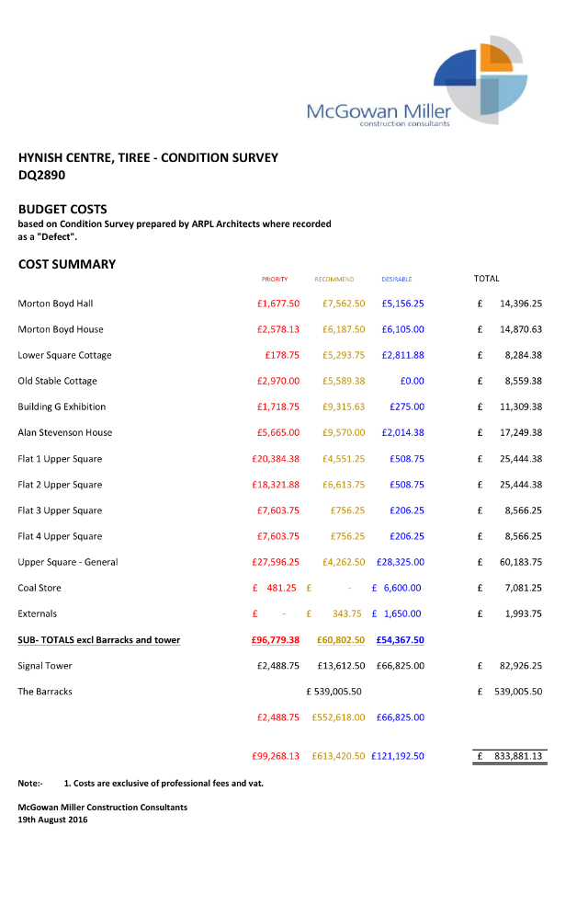

Appendix 3
Survey works of Hynish Centre, Isle of Tiree by ARPL Architects, August 2016 (see separate attachment)

Appendix 4
3-year Revenue Cashflow Projections (see separate attachment):
- Year one based on current activities
- Year two shows impact of Lower Square renovation – phased occupancy
- Year three shows full occupancy – full occupancy

Appendix 5
Risk Register
Risk | Probability | Impact | Resultant Outcomes | Mitigation
Ongoing maintenance & repair costs are high, ‘Barracks’ building is uninhabitable and is too expensive to renovate from current revenue stream. | HIGH | HIGH | - Income is eaten up by these costs.  - Project becomes unsustainable. | - Pursue income generating ideas/projects to ensure income is maximised.  - Investigate capital funding for renovation of ‘Barracks’.
Project success relies on developing ideas which the community may not have capacity to deliver. | MID | HIGH | - Project is not financially viable and will make a loss. | - Commission feasibility study to identify sustainable developments and an implementation plan, prior to purchase.  - Investigate initial revenue funding.
Lack of available funds for purchase & initial revenue. | LOW | HIGH | - Project cannot proceed without purchase fee and early revenue support. | - Build a strong business case, highlighting the socio-economic benefits that the project will bring, to ensure funding partners are engaged.
Lack of Community Volunteers to steer the project. | MID | HIGH | - Community volunteers not engaged and project lacks strategic vision and cohesive community planning. | - Engage community as early as possible to make them feel part of the project. Offer support through Trust staff time to lighten the initial load.

Appendix 6
SWOT Analysis
Strengths | Weaknesses
- Stunning Location  - Most building come with current income stream  - Totally unique buildings on Tiree  - Listed status can help attract visitors | - Buildings expensive to maintain due to age and listed status  - Buildings currently underused  - Location currently viewed by some as “isolated”  - Running costs are not currently met by trading income
Opportunities | Threats
- See section 6 for development possibilities  - Marketing campaign to promote current & future businesses including use of website and social media more effectively  - To engage the community in a project that can build confidence and skills/capacity  - Work with current owners to develop relationships with private funders/donors. | - Lack of volunteers coming forward to get involved  - Could become a financial drain without a detailed plan to increase trading income.

